- Project Title
- Award Number
- Award Total
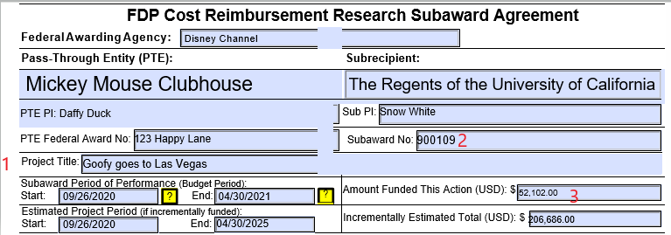
- Organization: Financial/HR Unit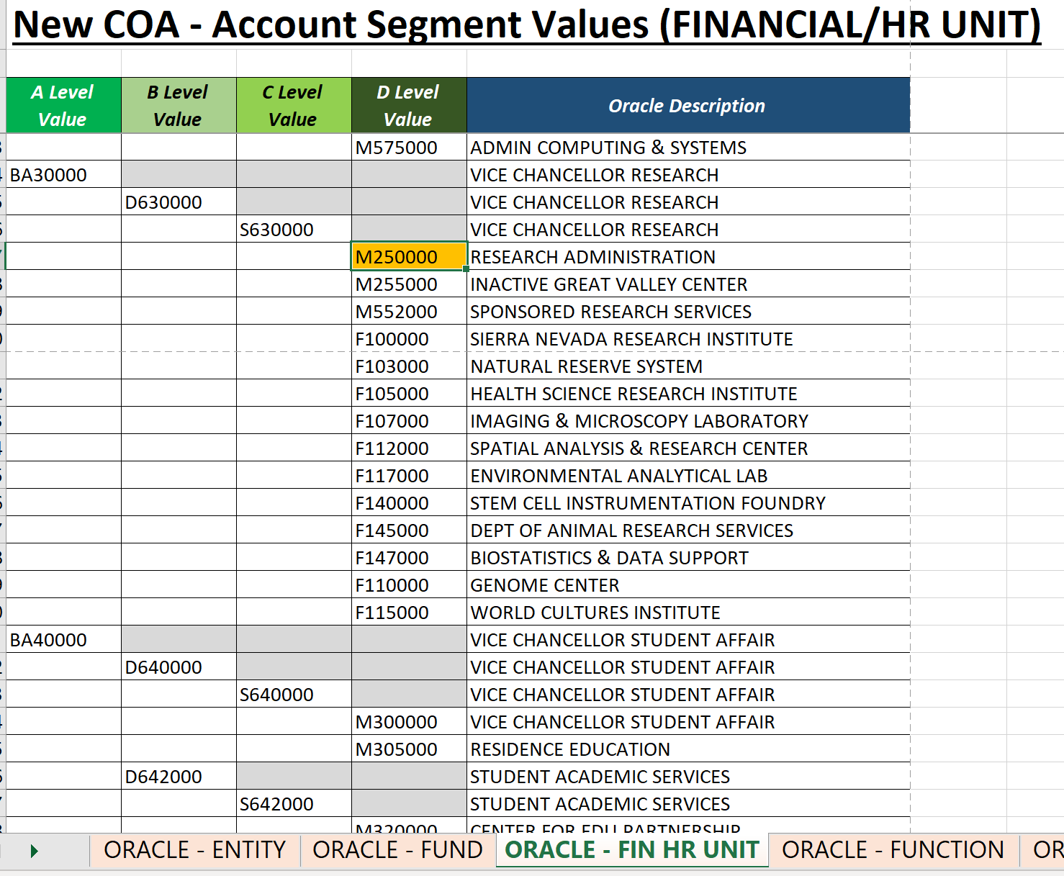
- Project Start Date
- Project End Date
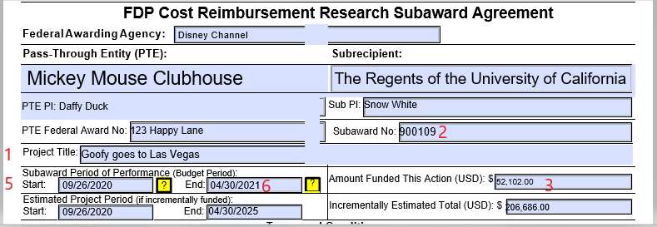
- Final Close Date Includes Sponsor’s Required Close Out Period:
  - State: 90 days
  - Federal: 120 days
  - UC: 45 days
  - Local or Private: 90 days
  - Or as defined by agreement
- Task Number-
  - The below list of the COA Function Segment align with the descriptor in this value.
  - Example: Research CAP (PI Initials), Research (PI Initials)
  - See examples provided on New Project Request Template for project specific tasks.
New COA - Function Segment Values
00 | DEFAULT FUNCTION
40 | INSTRUCTION
41 | SUMMER SESSION
42 | TEACHING HOSPITALS
43 | ACADEMIC SUPPORT
44 | RESEARCH
60 | LIBRARIES
61 | UNIVERSITY EXTENSION
62 | PUBLIC SERVICE
64 | OPERATIONS & MNTNCE OF PLANT
68 | STUDENT SERVICES
72 | INSTITU SUPPORT&GENERAL ADMIN
76 | AUXILIARY ENTERPRISES
78 | STUDENT FINANCIAL AID
79 | DEPARTMENT OF ENERGY LAB
80 | PROVISIONS FOR ALLOCATION
- Task Name-
- PI Name needs to be tied to item 8(a) above. See Excel template for examples
New COA - Function Segment Values
00 | DEFAULT FUNCTION
40 | INSTRUCTION
41 | SUMMER SESSION
42 | TEACHING HOSPITALS
43 | ACADEMIC SUPPORT
44 | RESEARCH
60 | LIBRARIES
61 | UNIVERSITY EXTENSION
62 | PUBLIC SERVICE
64 | OPERATIONS & MNTNCE OF PLANT
68 | STUDENT SERVICES
72 | INSTITU SUPPORT&GENERAL ADMIN
76 | AUXILIARY ENTERPRISES
78 | STUDENT FINANCIAL AID
79 | DEPARTMENT OF ENERGY LAB
80 | PROVISIONS FOR ALLOCATION

- Planned Start Date- If planned start date is different than period of performance.
  - Pre-Award Spending Authorization form is required and to be submitted with New Project Request Set-Up in ServiceNow.
- Planned End Date – If different than period of performance
- Billable – If task is required to bill. ‘Y’ or ‘N’
- Capitalizable – To identify purchases or costs to transfer to Assets.
- Fund - Reference Fund Segment Values - D Level Value
  - Sponsored Funds available below
New COA - Fund Segment Values
D Level Value | Oracle Description
20000 | FEDERAL CONTRACTS
20001 | FEDERAL GRANTS
20014 | DEPT OF HEALTH&HUMAN SERVICES
20015 | NATIONAL INSTITUTE OF JUSTICE
20400 | STATE CONTRACTS
20401 | STATE GRANTS
20402 | LOCAL CONTRACTS
20403 | LOCAL GRANTS
20700 | PRIVATE CONTRACTS
20701 | PRIVATE GRANTS

- Function – Reference Account Segment Values – B Level Values
New COA - Function Segment Values
B Level Value | Oracle Description
00 | DEFAULT FUNCTION
40 | INSTRUCTION
41 | SUMMER SESSION
42 | TEACHING HOSPITALS
43 | ACADEMIC SUPPORT
44 | RESEARCH
60 | LIBRARIES
61 | UNIVERSITY EXTENSION
62 | PUBLIC SERVICE
64 | OPERATIONS & MNTNCE OF PLANT
68 | STUDENT SERVICES
72 | INSTITU SUPPORT&GENERAL ADMIN
76 | AUXILIARY ENTERPRISES
78 | STUDENT FINANCIAL AID
79 | DEPARTMENT OF ENERGY LAB
80 | PROVISIONS FOR ALLOCATION

- Program – Reference Account Segment Values
New COA – Program Segment Values
000 | DEFAULT PROGRAM
B01 | SIERRA NEVADA RSRCH INTST
B02 | HEALTH SCIENCE RESEARCH INSTIT

- PI Code – For existing PI’s provide the code. For new PI’s generate a ServiceNow ticket and PPFM will create a new PI code.
  - Working on look up tool that will be made available on PPFM Website.
- Primary Sponsor – Awarding Agency
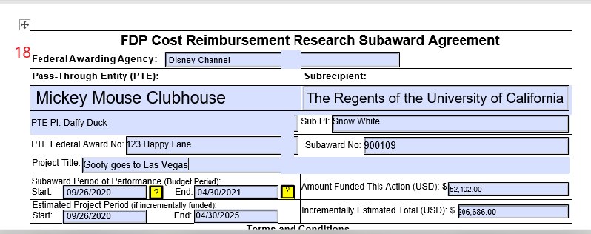
- Award Type – Reference Fund Segment Values – Level D
FEDERAL CONTRACTS
FEDERAL GRANTS
STATE CONTRACTS
STATE GRANTS
LOCAL CONTRACTS
LOCAL GRANTS
PRIVATE CONTRACTS
PRIVATE GRANTS

- Burden Schedule – Base, Indirect Rate, Reference Award.
  - FA-ONMTDC-55% - On Campus Activity, MTDC base, 55% rate
  - FA-OFFMTDC-26% - Off Campus Activity, MTDC base, 26% rate
  - FA – T – 0% - IDC Waived: Waiver on File
  - Salary & Wages – Compensation paid or accrued by the organization for employees working on the NSF-supported project during the grant period is allowable, in accordance with 2 CFR § 200.430, including Fringe Benefits.
  - TDC – Total Direct Cost, comprised of Salary and Wages, Intra-University Consulting, Federal Employees
- Budget – Based off the Budget of Award
  - Award Number – On the award letter
  - Award Period – Period 1, Period 2 (Year 1, Year 2)
  - Task Number - List of the COA Function Segment align with the descriptor in this value.
  - Fund – Reference Fund Segment D Level
  - Program – Reference Program Segment Values
  - Organization – Fin/HR Unit for Task
  - Year – Fiscal year of this budget
  - Period – Month of this budget
  - Scenario – One time or Recurring
  - Account- Reference Account Segment Values – E Level Values
  - Budget Amount – Dollar amount for each task

