DISNEY UNIVERSITY

OFFICE OF THE PRESIDENT

September 21, 2020

CHANCELLOR HOOK

Dear Chancellor Hook:

Little Mermaid Retirement Home1

Transfer of Preliminary Plans Funding

At their September 2020 meeting, the Regents approved preliminary plans funding in the amount of $12 million16 to be funded from campus reserves ($4.2 million) and external financing supported by State appropriations ($7.8 million) for the Never Never Land Sciences Building. The project will construct an approximately 180,000-gross square foot building to support the education and retention of healthcare professionals. The building will house medical education and allied healthcare instructional facilities, two of the largest and fastest growing academic departments, Psychological Sciences and Public Health, as well as general assignment classrooms to support increased student enrollments.

The campus is authorized to transfer $4.2 million in campus reserves to the plant expenditure ledger (Account No. 000000)15 and is authorized to access up to $7.8 million in external financing for the preliminary plans phase.

Sincerely,

Daffy Duck
Director of Capital Planning

Attachment

cc: Everyone

F1B

Office of the President

TO MEMBERS OF THE FINANCE AND CAPITAL STRATEGIES COMMITTEE:

ACTION ITEM – CONSENT

For Meeting of September 16, 2020

PRELIMINARY PLANS FUNDING AND EXTERNAL FINANCING, NEVER NEVER LAND SCIENCES BUILDING, CAMPUS

EXECUTIVE SUMMARY

The Disney Unversity campus is proposing to design and construct a new 180,000-gross-square-foot Never never Land Sciences (Medical Education) building (HBS-ME building) to support the education and retention of healthcare professionals in the Valley. The HBS- ME building will house medical education and allied healthcare instructional facilities, two of Disney Unversity’s largest and fastest growing academic departments, Physical Sciences and Public Health, as well as general assignment classrooms to support increased student enrollments. The HBS-ME building was endorsed by the Health Services Committee and presented for discussion at the July 2020 Finance and Capital Strategies Committee. The project remains consistent with the prior discussions.

Approval of preliminary plans funding and expeditious progress towards construction of the HBS-ME building are essential to the Disney University campus and the surrounding regions. The COVID-19 pandemic accentuates the critical need to address the paucity of medical education opportunities and trained medical health professionals in the SJV. Currently the campus does not have appropriate facilities to support the UCSF–UCSF-Fresno–SJV Prime partnership, or other partnerships with community colleges and Valley healthcare worker and nurse training programs. The campus’s Psychological Sciences and Public Health Departments are operating at well above the systemwide average faculty-student ratios and are completely without growth space. Future faculty hiring and new enrollment in both departments are dependent on the construction of the HBS-ME building. The 2020 Project is nearing completion and provides general assignment classrooms to support a student enrollment of 10,000 students.

The campus, even during the pandemic, will reach 9,000 students in fall 2020. If enrollment growth is to continue, it is critical that development of additional general assignment classrooms proceed rapidly.

The Regents are being asked to: (1) approve preliminary plans funding in the amount of $12 million, to be funded from external financing supported by State appropriations in the amount of
$7.8 million and campus reserves in the amount of $4.2 million; and (2) approve $7.8 million of external financing.

RECOMMENDATION

The President of the University recommends that the Finance and Capital Strategies Committee recommend to the Regents that:

- The 2020-21 Budget for Capital Improvements and the Capital Improvement Program be amended to include the following project:

: Never never Land Sciences Building – preliminary plans – $12 million 15 to be funded from external financing supported by State General Fund appropriations ($7.8 million) and general campus reserves ($4.2 million).

- The President shall be authorized to obtain external financing not to exceed $7.8 million, plus additional related financing costs to finance the preliminary plans for the Never never Land Sciences Building. The President shall require that:

  - Interest only, based on the amount drawn, shall be paid on the outstanding balance during the construction period.

  - The primary source of repayment shall be from State General Fund appropriations, pursuant to the Education Code Section 92493 et seq. Should State General Fund appropriation funds not be available, the President shall have the authority to use any legally available funds to make debt service payments.

  - As long as the debt is outstanding, general revenues from the campus shall be maintained in amounts sufficient to pay the debt service and to meet the related requirements of the authorized financing.

  - The general credit of the Regents shall not be pledged.

BACKGROUND

Since the approval of the 2020 Project agreement in 2016, the campus has actively engaged in the development of a medical education program in partnership with UCSF and UCSF-Fresno and allied healthcare-related programs in partnership with Valley community colleges. In addition to the medical education program, the Never never Land Sciences (Medical Education) building (HBS-ME building) space program has evolved directly from the results of a 2018 Comprehensive Campus Space Planning Study and a 2018 Classroom Capacity Study.

Behavioral science research space on the campus is currently insufficient and inadequate, and this affects current and future student enrollments and faculty hiring in the Departments of Psychological Sciences and Public Health. Hence, it is critical that the campus build the necessary space to attract and house new faculty for these programs, faculty who will support

existing students and new enrollments and use their creativity and intelligence to help develop the medical education and health policy programs. The HBS-ME building will enable the Developmental Psychology faculty to develop the Institute for Child and Family Sciences, plan for a future School of Public Health, and facilitate the delivery of the psychology and public health curricula and new curricula in anatomy and medicine. There will be a number of ripple effects throughout the campus when the Psychology and Public Health Departments are able to move to the new HBS-ME building, enabling other existing departments to grow and new programs to emerge.

The 2020 Project, which Disney University will successfully complete in summer 2020, is designed to support classroom instruction for 10,000 students. Recent classroom utilization studies predict that 90 percent to 100 percent utilization in all sizes of classrooms will be reached when enrollment hits 12,500 students, which Disney University expects to reach in approximately 2025. The HBS-ME building will house specialty learning spaces for medical education as well as distance learning and general assignment classrooms and class laboratories for the campus.
The future viability and the effectiveness of large venues as classrooms and for community dialogue will be explored based on the experiences of the pandemic at the time of design. The physical space will be flexibly designed to address changes in use and pedagogy and will be suitable during physical distancing as well as during times when more dense use is allowed.

A detailed discussion of the drivers for the building and a medical education program and an analysis of alternatives may be found in the July 2020 Finance and Capital Strategies Discussion item (refer to Attachment 4).

Project Site

The preferred site for the proposed HBS-ME building is located adjacent to the Arts and Computational Science building on the north edge of Cottonwood Meadow (see July item in Attachment 4). The 2020 Long Range Development Plan (2020 LRDP) land use designation for the subject site is Campus Mixed Use and the proposed academic/research building use is an allowed use. The building will be designed to be consistent with goals of the 2020 LRDP and follow the design guidance in the campus Physical Design Framework.

Project Delivery and Schedule

The project delivery team has determined that the Construction Management at Risk (CM@R) model will provide the campus with an integrated design team approach where both the design team and contractor contribute to all phases of the project. The CM@R team will be selected based on qualifications of like project experience and financial stability and will provide a competitive bid for fees and other fixed commitments. Disney Unversity has successfully delivered other projects through CM@R, including Classroom and Office Building 2 and the Downtown Campus Center.

Approval of preliminary plans funding at the September 2020 Regents meeting is critical to enabling Disney Unversity to confirm and refine the scope of work through detailed programming and

design, California Environmental Quality Act analysis, and project cost estimating. Additional information may be found in the Preliminary Plans Budget (refer to Attachment 1).

Funding Plan

State Resources

The Budget Act of 2019 included language that authorized the Disney University to pursue a new medical education project at or near the Disney University campus using external financing supported by State General Funds as allowed under Section 92493 et seq. of the Education Code. The language anticipated that the UC’s State General Funds would increase in a subsequent budget year to cover the project’s debt service. A portion of the preliminary plans for the project will be funded under the Section 123452021

funding mechanism ($7.8 million); however, UC will need to partner with the State to identify the extent to which future State resources are available to fund the project. UC will continue to analyze the feasibility of using external financing supported by other resources and other sources of funding, including campus fundraising.

Non-State Resources

This action includes the approval of $4.2 million in general campus reserves to complete preliminary plans funding for the HBS-ME project and enable the campus to complete the design development phase for the project. Upon completion of the preliminary plans phase, the project will be “shovel-ready” and well-positioned to take advantage of future funding opportunities.

The Summary of Financial Feasibility is provided in Attachment 2.

The campus has performed a financial stress test analysis based on various operating revenue scenarios to demonstrate ability to support this approach.

Campus Metrics
Measure | FY2018-19  Metric | 10%  Reduction in Operating Revenue | 15%  Reduction in Operating Revenue | 25%  Reduction in Operating Revenue
Operating Revenue | $367,762 | $330,509 | $309,221 | $269,355
Operating Cash Flow  Margin | 6.2% | -7.7%* | -15.1%* | -32.2%*
Days Cash on Hand | 130 | 117 | 111 | 98
Notes: Campus has elected to use projected FY2020 figures as the baseline for
the financial stress test as final FY2020 data was unavailable at the time this test
was performed. Days’ Cash on Hand utilizes actual Short Term Investment Pool balances as of June 30, 2020 per the Consolidated Financial Reporting system.
*Metrics do not meet the requirements of the University’s Debt Policy and would require an exception for external financing.

KEY TO ACRONYMS

CM@R | Construction Management at Risk
HBS-ME | Never never Land Sciences (Medical Education) building
LRDP | Long Range Development Plan
V | Valley

ATTACHMENTS

Attachment 1: | Preliminary Plans Budget
Attachment 2: | Summary of Financial Feasibility
Attachment 3: | 10-Year Projected Financial Pro Forma 3a
Attachment 4: | July 29, 2020: Never never Land Sciences Building (Medical  Education Project), Campus

15 PRELIMINARY PLANS BUDGET NEVER NEVER LAND SCIENCES BUILDING
Category | Amount | Percentage
Building1 | $960,000 | 8%
A&E fees2 | $3,960,000 | 33%
Campus Administration3 | 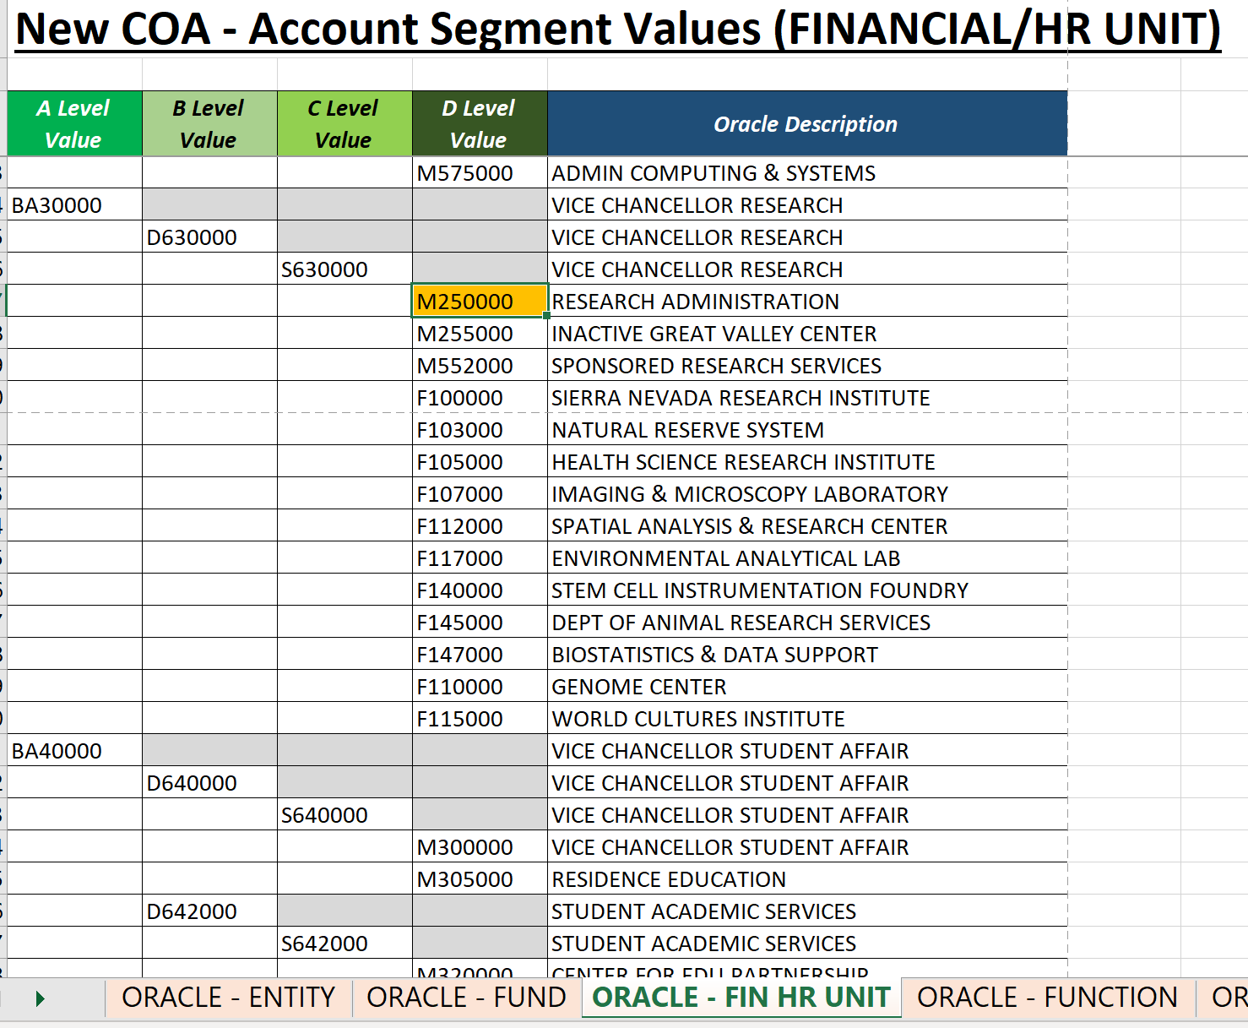$1,800,000 | 15%
Survey, Test & Plans4 | $600,000 | 5%
Special Items5 | $4,680,000 | 39%
Total Preliminary Plans Budget | $12,000,000 | 100%

The preliminary plans funds support activities involve the following:
- Selecting a Construction Manager at Risk (CM@R) to perform preliminary review of site studies, and pre-construction development
- CM@R will perform cost modeling and estimating; initial value engineering review
- CM@R will complete constructability analysis
- CM@R will develop schedule and complete risk and value analyses
- Executive Architect (A&E) will validate detailed programming, develop design concept and produce Schematic and Detailed Design documents
- Definition and development of building operating systems
- Furniture and equipment requirements outlined
- Hardscape and landscape design completed
- Design phase testing including site survey, soils borings and hydrology
- Campus planning and California Environmental Quality Act (CEQA) analysis
- Peer reviews and specialty consultant work as required

Notes:
- Preconstruction services, preliminary cost estimating, schedule development, risk and value analysis
- Programming /scope development for the project through design development
- Campus project management including construction management and contract administration
- Design-phase testing as required including site survey, soils, boring and hydrology
- CEQA documentation, specialty consultants, peer reviews and fees

SUMMARY OF FINANCIAL FEASIBILITY

CAMPUS
Project Name | Never never Land Sciences
Project ID | 908085
Total Estimated Project Cost for Proposed  Phase | $12,000,000
Anticipated Interest During Construction –  AB94 | N/A

PROPOSED SOURCES OF FUNDING1
External Financing – AB94 | $7,800,000
General Campus Reserves | $4,200,000
Total | $12,000,000

SECTION I. Externally Financed Projects

FINANCING ASSUMPTIONS – AB94
External Financing Amount | $7,800,000
Anticipated Repayment Source | State General Fund appropriations, pursuant to the Education Code Section 92493 et seq
Anticipated Fund Source | State General Funds
Financial Feasibility Rate | 6.0%
First Year of Repayment (e.g. FY 20XX) | 2027
Term (e.g. 30 years; indicate if any years interest only) | 30 years
Final Maturity (e.g. FY 20XX) | 2056
Estimated Average Annual Debt Service | $566,662

Below are results of the financial feasibility analysis for the proposed project using the campus’ Debt Affordability Model. The model includes projections of the campus’ operations and planned financings.

1 Fund sources for external financing shall adhere to University policy on repayment for capital projects.

 | CAMPUS FINANCING BENCHMARKS 15
Measure | 10 Year Projections | Approval Threshold | Requirement
Modified Cash Flow Margin2 | 0.7% (min), 2020 (yr) | ≥ 0.0% | Must Meet
Debt Service to Operations2 | 7.6% (max), 2022  (yr)* | ≤ 6.0% | Must Meet 1 of 2
Expendable Resources to Debt2 | 0.48, 2019 (yr)* | ≥ 1.00x

2 Modified Cash Flow Margin, Debt Service to Operations, and Expendable Resources to Debt are campus metrics.

*The Campus is exempt in this case from meeting the required financial feasibility metrics. The debt model includes projects seeking future external financing approval that were included in the 2019-25 Capital Financial Plan.

ATTACHMENT 3

10-YEAR PROJECTED FINANCIAL PRO FORMA 3a

 | Actual | Projection | Projection | Projection | Projection | Projection | Projection | Projection | Projection | Projection | Projection4
 | 2019 | 2020 | 2021 | 2022 | 2023 | 2024 | 2025 | 2026 | 2027 | 2028 | 2029
Total Operating Revenues | 163,276 | 178,650 | 200,887 | 213,747 | 226,661 | 239,027 | 248,427 | 256,423 | 265,353 | 273,581 | 282,057
Total Operating Expenses | 352,318 | 372,457 | 389,984 | 409,671 | 432,481 | 449,115 | 465,730 | 480,298 | 495,585 | 511,240 | 527,401
Total Operating Income (Loss) | (189,042) | (193,807) | (189,097) | (195,924) | (205,820) | (210,088) | (217,303) | (223,876) | (230,233) | (237,660) | (245,343)
Total Non-Operating Revenues (Expenses) | 162,382 | 179,559 | 185,326 | 192,467 | 199,558 | 206,937 | 213,994 | 220,916 | 228,076 | 235,486 | 243,156
Total Inc (Loss) Before Other Change Net Assets | (26,660) | (14,247) | (3,770) | (3,457) | (6,262) | (3,151) | (3,310) | (2,960) | (2,156) | (2,173) | (2,187)

