- PROJECT TITLE: Capital Major – Little Mermaid Retirement Home
From Requester

- ORGANIZATION: Financial/HRUnit
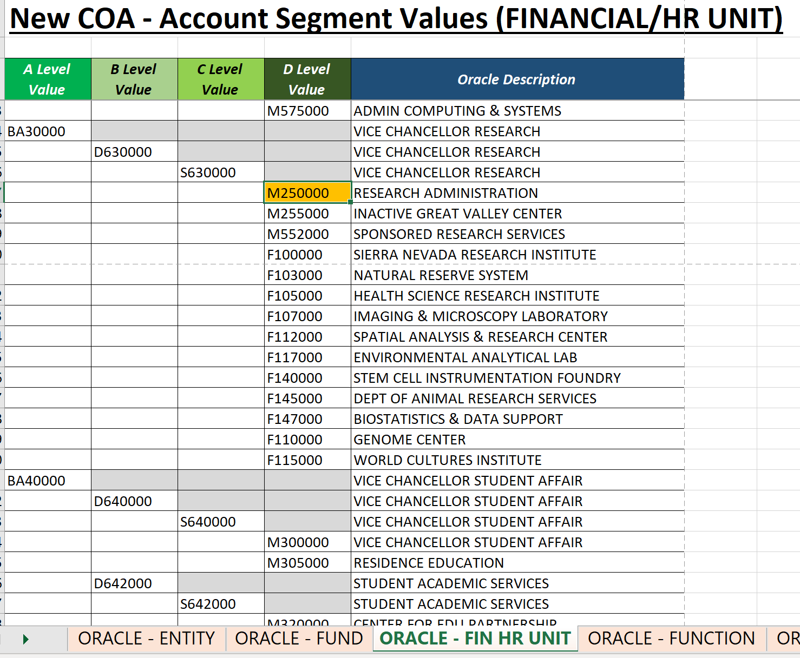

- Project Start Date
From Requester

- Project End Date – From Requester

- Task Number-
- The below list of the COA Function Segment align with the descriptor in this value.
- Example: Operation Expense – Fund, Capital Expense - Fund
- See examples provided on New Project Request Template for project specific tasks
 | FUNCTION CATEGORIES
00 | DEFAULT FUNCTION
40 | INSTRUCTION
41 | SUMMER SESSION
42 | TEACHING HOSPITALS
43 | ACADEMIC SUPPORT
44 | RESEARCH
60 | LIBRARIES
61 | UNIVERSITY EXTENSION
62 | PUBLIC SERVICE
64 | OPERATIONS & MNTNCE OF PLANT
68 | STUDENT SERVICES
72 | INSTITU SUPPORT&GENERAL ADMIN
76 | AUXILIARY ENTERPRISES
78 | STUDENT FINANCIAL AID
79 | DEPARTMENT OF ENERGY LAB
80 | PROVISIONS FOR ALLOCATION

- Task Name-
  - PI Name needs to be tied to item 5(a) above. See Excel template for examples
 | FUNCTION CATEGORIES
00 | DEFAULT FUNCTION
40 | INSTRUCTION
41 | SUMMER SESSION
42 | TEACHING HOSPITALS
43 | ACADEMIC SUPPORT
44 | RESEARCH
60 | LIBRARIES
61 | UNIVERSITY EXTENSION
62 | PUBLIC SERVICE
64 | OPERATIONS & MNTNCE OF PLANT
68 | STUDENT SERVICES
72 | INSTITU SUPPORT&GENERAL ADMIN
76 | AUXILIARY ENTERPRISES
78 | STUDENT FINANCIAL AID
79 | DEPARTMENT OF ENERGY LAB
80 | PROVISIONS FOR ALLOCATION

- Planned Start Date- If planned start date is different than period of performance, or if applicable.
- Planned End Date – If different than period of performance, or if applicable
- Billable – If task is required to bill. N
- Capitalizable – To identify purchases or costs to transfer to Assets.
- Reference Fund Segment Values - D Level Value
  - Non-Sponsored Funds available below
UCM Fund
14000 | TUITION
14001 | OFFSET CAPITAL EXP TUITION&FEE
19900 | STATE GENERAL FUND

- Function – Reference Account Segment Values – B Level Values
New COA - Function Segment Values
00 | DEFAULT FUNCTION
40 | INSTRUCTION
41 | SUMMER SESSION
42 | TEACHING HOSPITALS
43 | ACADEMIC SUPPORT
44 | RESEARCH
60 | LIBRARIES
61 | UNIVERSITY EXTENSION
62 | PUBLIC SERVICE
64 | OPERATIONS & MNTNCE OF PLANT
68 | STUDENT SERVICES
72 | INSTITU SUPPORT&GENERAL ADMIN
76 | AUXILIARY ENTERPRISES
78 | STUDENT FINANCIAL AID
79 | DEPARTMENT OF ENERGY LAB
80 | PROVISIONS FOR ALLOCATION

- Program – Reference Account Segment Values
New COA – Program Segment Values
000 | DEFAULT PROGRAM
B01 | SIERRA NEVADA RSRCH INTST
B02 | HEALTH SCIENCE RESEARCH INSTIT

- PI Code: For existing PI’s provide the code. For new PI’s generate a ServiceNow ticket and PPFM will create a new PI code.
  - Working on look up tool that will be made available on PPFM Website.

Budget request Information

- Account Number - 590001
- Budget Amount – Amount Requested
- CC0A (source of funds), if applicable
1011-FUND-BUDGETARY ORG-ACCOUNT-FUNCTION-PROGRAM-PROJECT NUMBER-000-000000-0000-000000-000000

